Project Design Phase
Solution Architecture

Date | 09 september 2026
Team ID
Project Name | ServiceNow-Based Employee Laptop Request Application
Maximum Marks | 4 Marks

Solution Architecture:
The Solution Architecture for the proposed ServiceNow-Based Employee Laptop Request Application bridges the gap between employee requirements and an automated IT service management solution. Its goals are to:
- Identify the best ServiceNow-based approach to automate the employee laptop request and approval process.
- Define the structure, components, workflows, and interactions of the application for employees, managers, and IT support teams.
- Specify key features and solution requirements, including request submission, automatic request numbering, approvals, assignment, notifications, and status tracking.
- Design an efficient end-to-end workflow that manages laptop requests from submission through approval, IT processing, allocation, and closure.
- Provide clear technical specifications for developing, managing, and delivering the solution using ServiceNow modules, workflows, forms, and automation features.

Example - Solution Architecture Diagram:
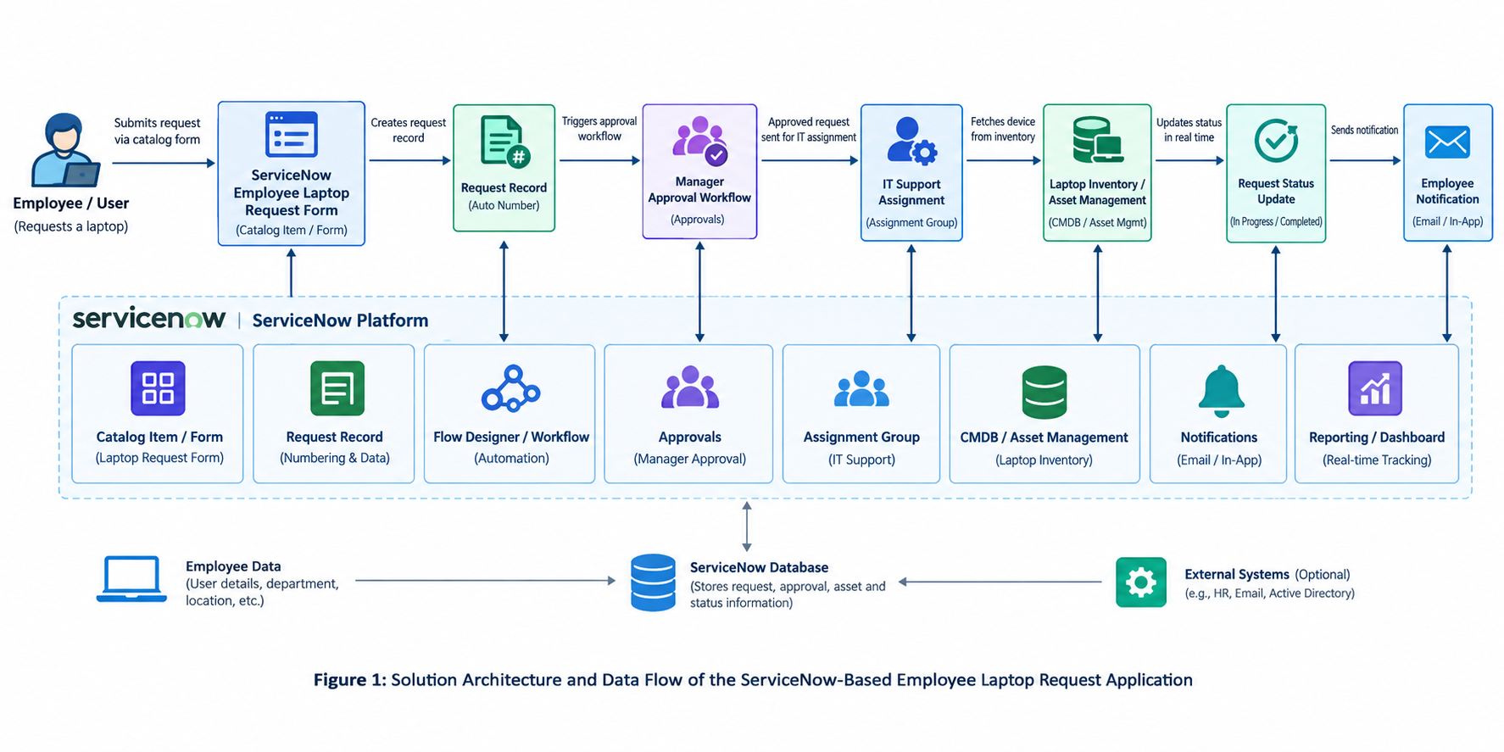

Figure 1: Architecture and data flow of the voice patient diary sample application
Reference:
https://www.servicenow.com/docs/r/it-asset-management/enterprise-asset-management/exploring-eam.html?utm_source=chatgpt.com

